**How to uninstall NVidia drivers and reinstall the drivers**

**Uninstalling Nvidia Drivers**

**Step1:** run the below commands with Sudo privileages

**nvidia-installer --uninstall**

**sudo apt remove nvidia-\***

**Step 2:**Figureout the Nvidea driver model

Go to **About** on the Ubuntu you will get it  
 **Nvidea @RTX2080 Ti**

**Step3: need cuda driver( for Pytorch)**

**Go to pytorch.org( not required)**

**Select CUDA 11.3**

**Step 4: go to google and type CUDA 11.3 and download the Cuda Drivers**

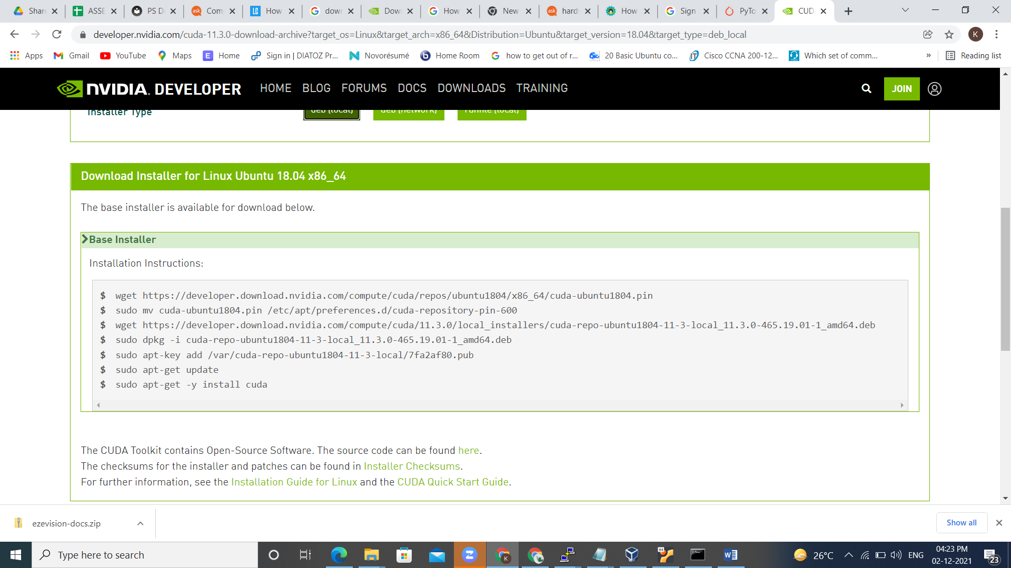

**Run the below commands for Cuda Driver installation**

wget https://developer.download.nvidia.com/compute/cuda/repos/ubuntu1804/x86_64/cuda-ubuntu1804.pin

sudo mv cuda-ubuntu1804.pin /etc/apt/preferences.d/cuda-repository-pin-600

wget https://developer.download.nvidia.com/compute/cuda/11.3.0/local_installers/cuda-repo-ubuntu1804-11-3-local_11.3.0-465.19.01-1_amd64.deb

sudo dpkg -i cuda-repo-ubuntu1804-11-3-local_11.3.0-465.19.01-1_amd64.deb

sudo apt-key add /var/cuda-repo-ubuntu1804-11-3-local/7fa2af80.pub

sudo apt-get update

sudo apt-get -y install cuda

**Installing NVIDEa Drivers**

**First nned to check cuda compatible with Nvidea drivers site (**[**https://docs.nvidia.com/deploy/cuda-compatibility/**](https://docs.nvidia.com/deploy/cuda-compatibility/)**)**

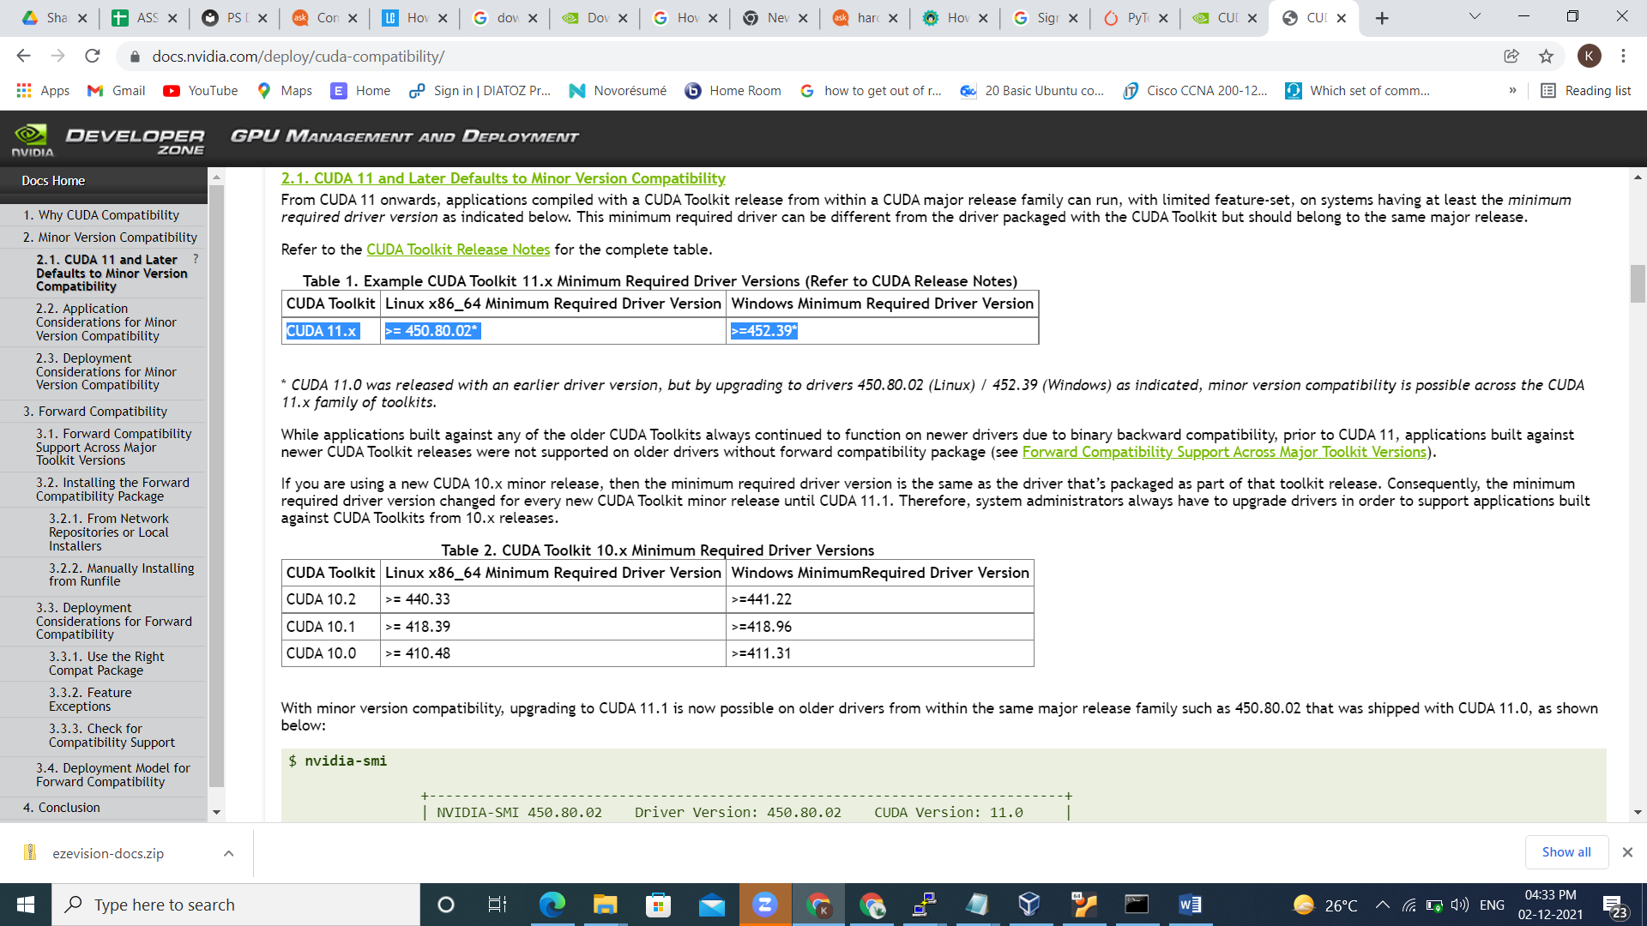

Now download Nvidea drivers for Linux,Windows

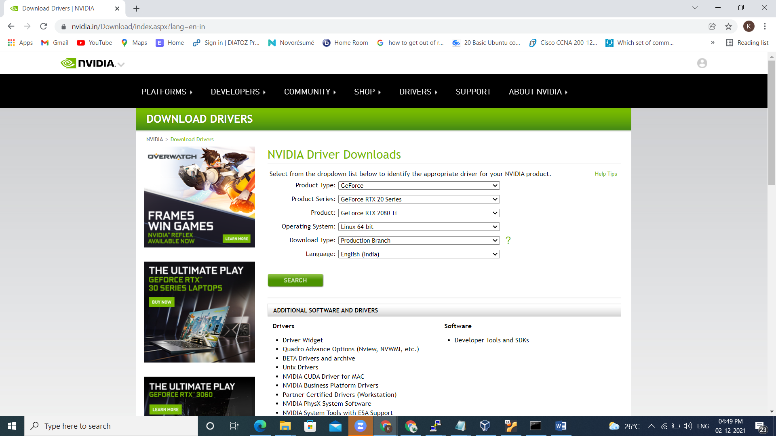

Select the respective drivers and Supported GPU model

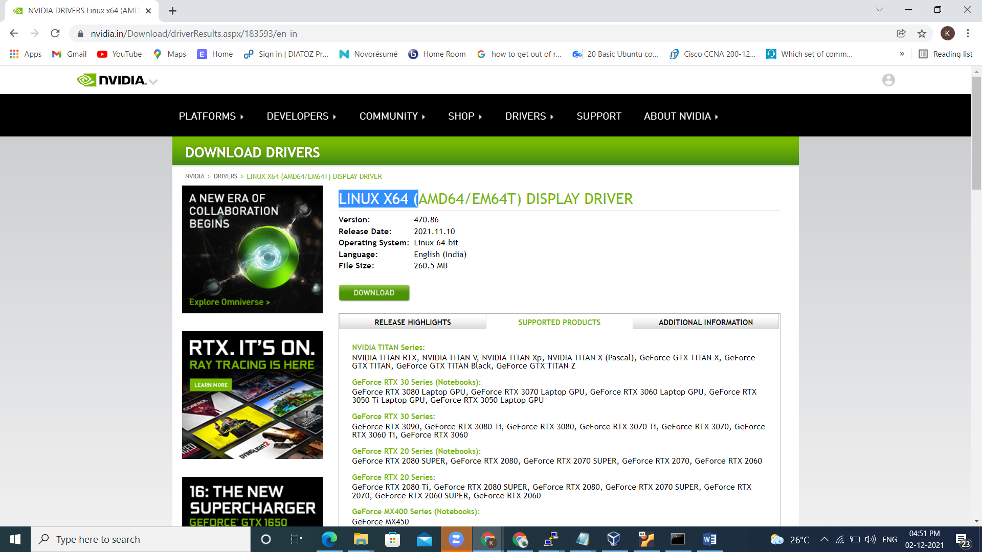

Download the drivers and install it

**Installing Nvidia Drivers**

Now install the driver throught command

**API Key generation for Nvidia NGC**

Create Nvidia **NGC account**

Go to respective url[**https://ngc.nvidia.com/setup**](https://ngc.nvidia.com/setup)

